**Task9-Gemini**

**Aligning Elements in CSS**

CSS offers a variety of properties to control the alignment of elements on a web page. These properties can be used to position elements horizontally, vertically, or both.

**Horizontal Alignment**

* **text-align property:** This property is used to align the text within a block-level element.
  + left: Aligns the text to the left side of the element.
  + center: Centers the text within the element.
  + right: Aligns the text to the right side of the element.
  + justify: Justifies the text, distributing spaces between words to fill the entire width of the element.

**Vertical Alignment**

* **vertical-align property:** This property is used to align the content of an inline-level element relative to its baseline.
  + baseline: Aligns the baseline of the element with the baseline of the parent element.
  + top: Aligns the top edge of the element with the top edge of the parent element.
  + bottom: Aligns the bottom edge of the element with the bottom edge of the parent element.
  + middle: Centers the element vertically within the parent element.

**Display Property**

The display property determines how an element is displayed. It can affect the element's layout, size, and behavior.

* **block:** The element is displayed as a block, taking up the full width of its parent container.
* **inline:** The element is displayed as inline text, flowing with the surrounding text.
* **inline-block:** The element is displayed as an inline element, but it can have its own width and height.
* **flex:** The element becomes a flex container, enabling flexible box layout.

**Example HTML Document**

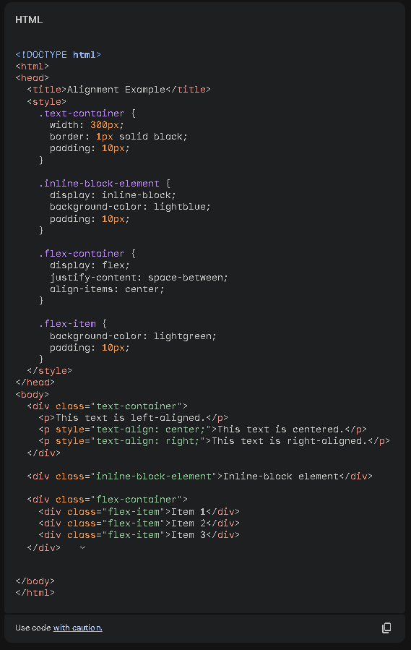

**Result:**

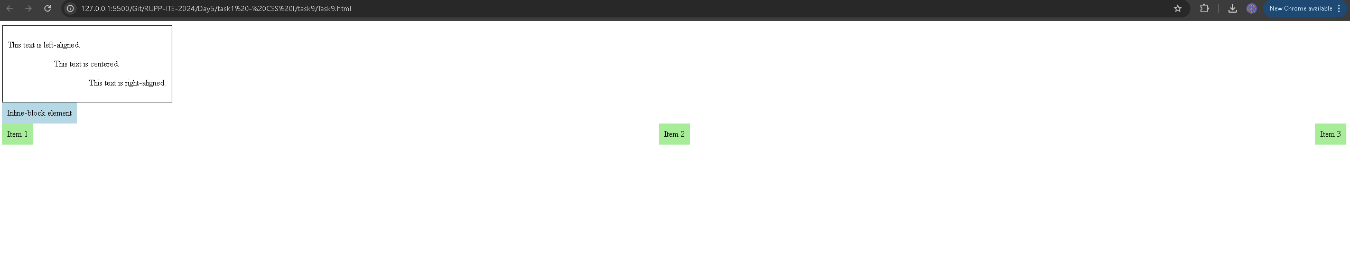

**Explanation:**

* The text-container div demonstrates different text alignment techniques using the text-align property.
* The inline-block-element div shows how an inline-block element can have its own width and height.
* The flex-container and flex-item divs showcase the use of flexbox for aligning elements horizontally and vertically. The justify-content property controls horizontal alignment, and the align-items property controls vertical alignment.

This example provides a basic understanding of how to align elements in CSS using various techniques and properties. By experimenting with different combinations, you can achieve a wide range of layouts for your web pages.